**USER-MANUAL OF IPR**

* How to open the IPR in any browser on LAN connected PC’s

Link: <http://192.168.0.27:8080/ipr/main.jsp>

Screen appearance after opening of above link as follows:

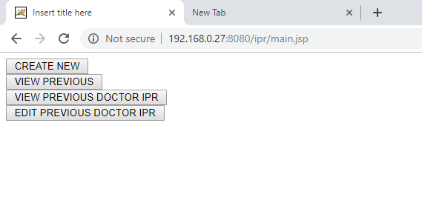

* How to create new IPR
* Click on CREATE NEW button

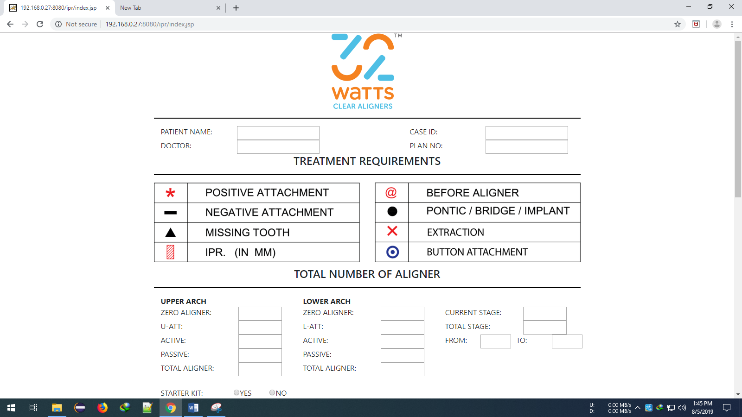

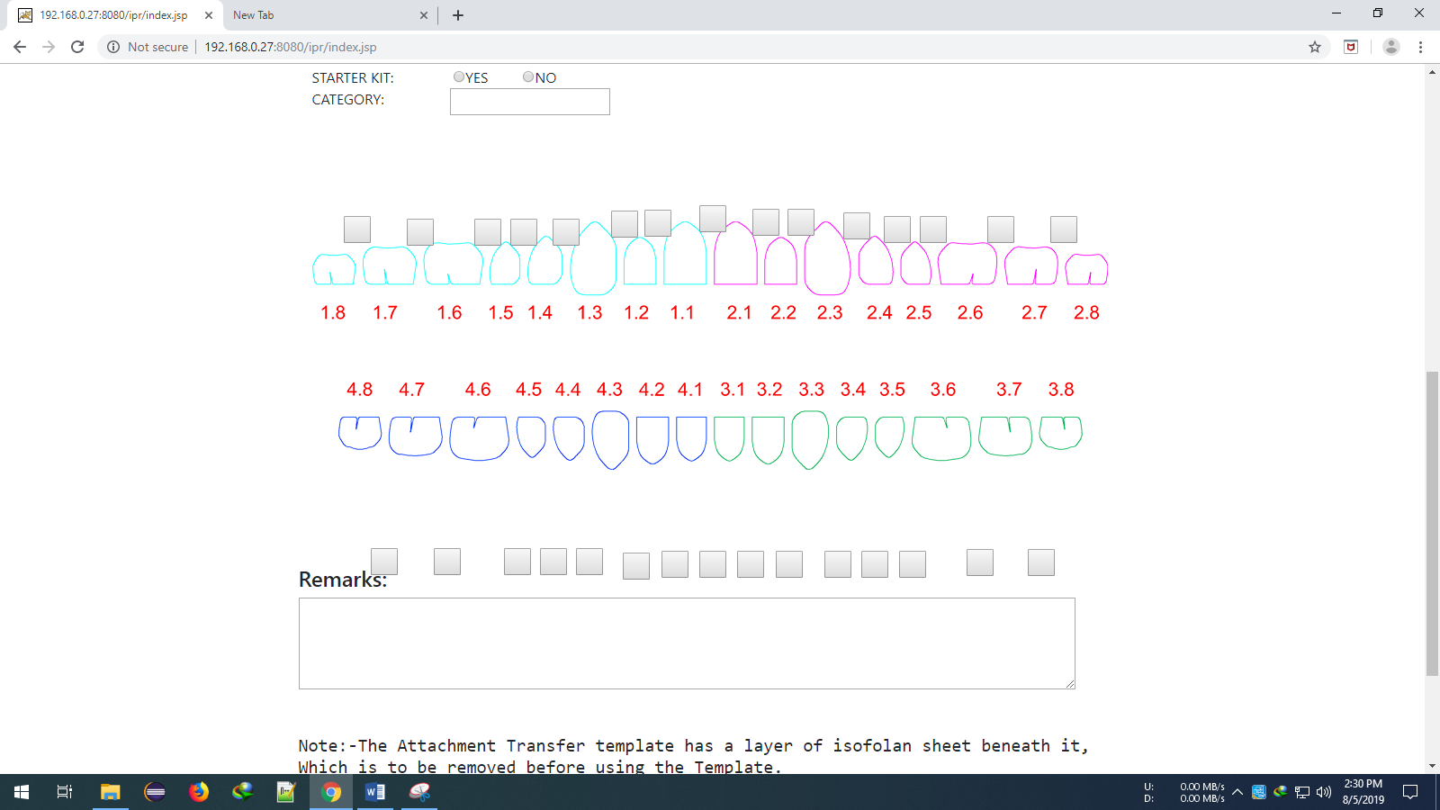

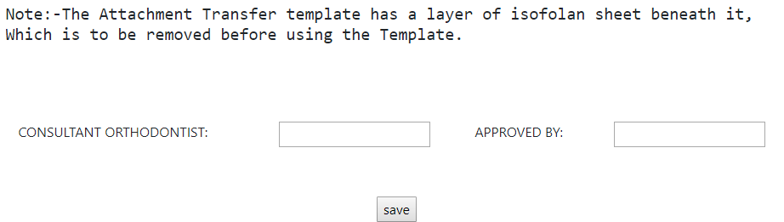

* Fill up all the Entries

Some must filled entries are:

* CASE ID(only numbers no decimal number)
* PATIENT NAME
* DOCTOR NAME
* PLAN NO(it can be character,number and combination of both)
* ALL UPPER AND LOWER ARCH DETAILS(only numbers no decimal number)
* TOTAL STAGE(only numbers no decimal number)
* FROM(only numbers no decimal number)
* TO(only numbers no decimal number)
* If You left some entries blank, then By Default those are null and saved in database as null.
* CURRENT STAGE
* STARTER KIT
* CATEGORY
* REMARKS
* CONSULTANT ORTHODONTIST
* APPROVED BY
* How to attach attachments to the tooth
* Hover your mouse on any tooth.
* Black colour button appears.
* Click on button.
* Dropdown menu displays on screen.
* Select one attachment. That’s it.

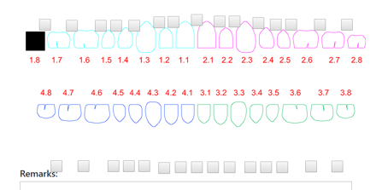

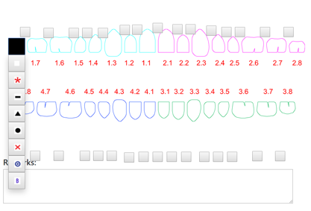

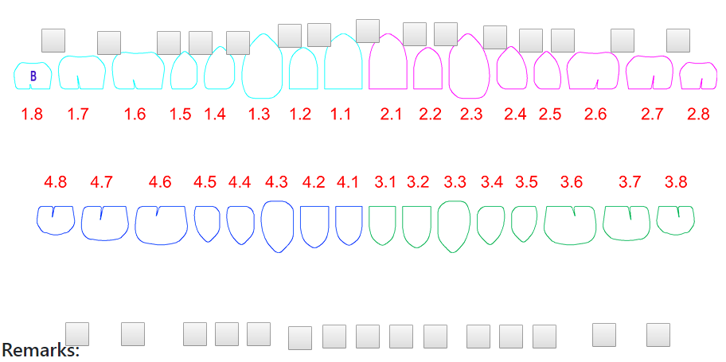

* How to change attachments of the tooth
* Hover your mouse on any tooth.
* Black colour button appears with previously added attachment.
* Click on black part of the button.
* Dropdown menu displays on screen.
* Select one attachment. That’s it.

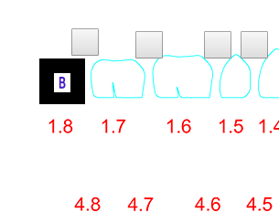

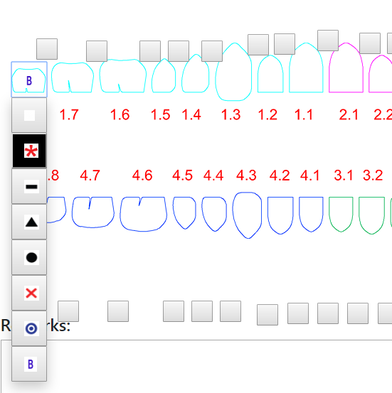

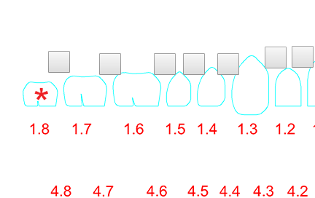

* How to remove attachments from the tooth
* Hover your mouse on any tooth.
* Black colour button appears with previously added attachment.
* Click on black part of the button.
* Dropdown menu displays on screen.
* Select white attachment. That’s it.



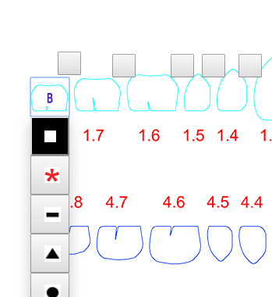

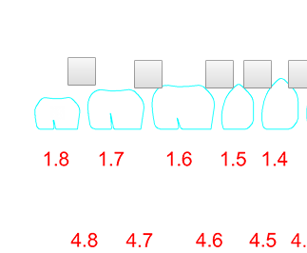

* How to attach IPR between two teeth of upper section
* Click on Light Grey button between teeth.(Highlighted by red color)
* A ipr will appear.
* Click just below the @.
* And fill Thickness.(**ONLY IN DECIMAL AND MUST FILLED**)
* Click just Right of the @.
* And fill before aligner.(**ONLY IN NUMBERS AND MUST FILLED**)

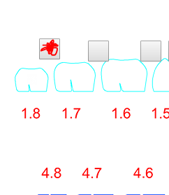

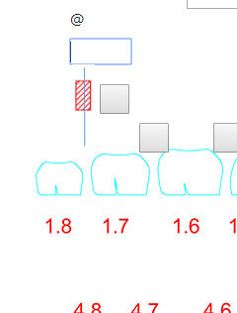

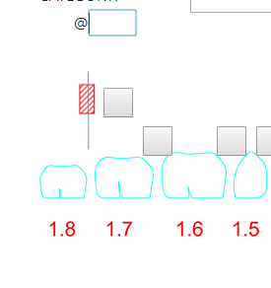

* How to remove IPR between two teeth of upper section
* Click on light grey button just right side of the attached IPR. (Highlighted by red color)
* IPR will be remove or disappears.

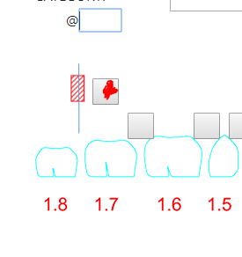

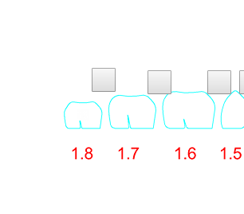

* How to attach IPR between two teeth of Lower section
* Click on Light Grey button between teeth but just below in direction. (Highlighted by red color)
* A ipr will appear.
* Click just above the @.
* And fill Thickness. (**ONLY IN DECIMAL AND MUST FILLED**)
* Click just Right of the @.
* And fill before aligner. (**ONLY IN NUMBERS AND MUST FILLED**)

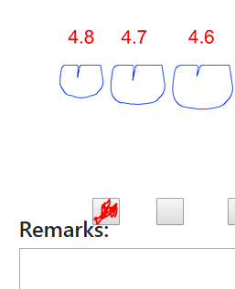

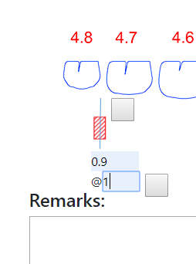

* How to remove IPR between two teeth of lower section
* Click on light grey button just right side of the attached IPR. (Highlighted by red color)
* IPR will be remove or disappears.

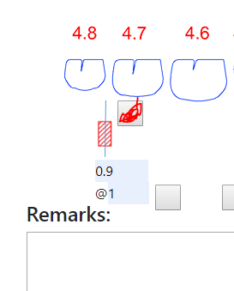 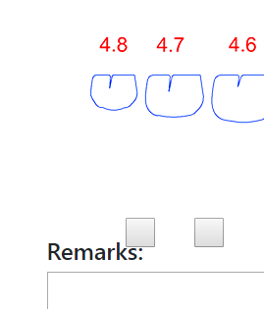

* How to save IPR.
* Click on Save button
* If page will redirect to index.jsp then ipr not saved because Case Id and Plan number already exists. You can create different plan numbers for same case Id or you have to change case id.
* If page will redirect to main.jsp page then IPR saved successfully.

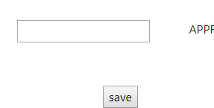

* How to Display Locally used IPR view
* Click on VIEW PREVIOUS button on main page.
* login.jsp appears.
* Fill correct case id and plan no. If there is some mistake in case id and plan no then page will redirect to same page i.e login.jsp then again fill details.
* Click on get ipr.
* Locally used IPR will display.
* Press ctrl+p.
* Default chrome print appears.
* Destination: Save as PDF
* Pages: All
* Pages per sheet: 1
* Margins : NONE
* Options: Make unchecked Background Graphics
* Then click on blue color save button
* And save where you want.

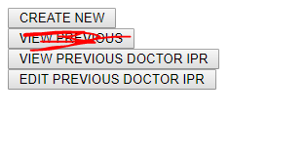

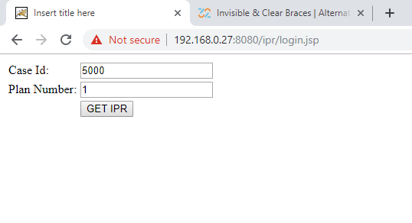

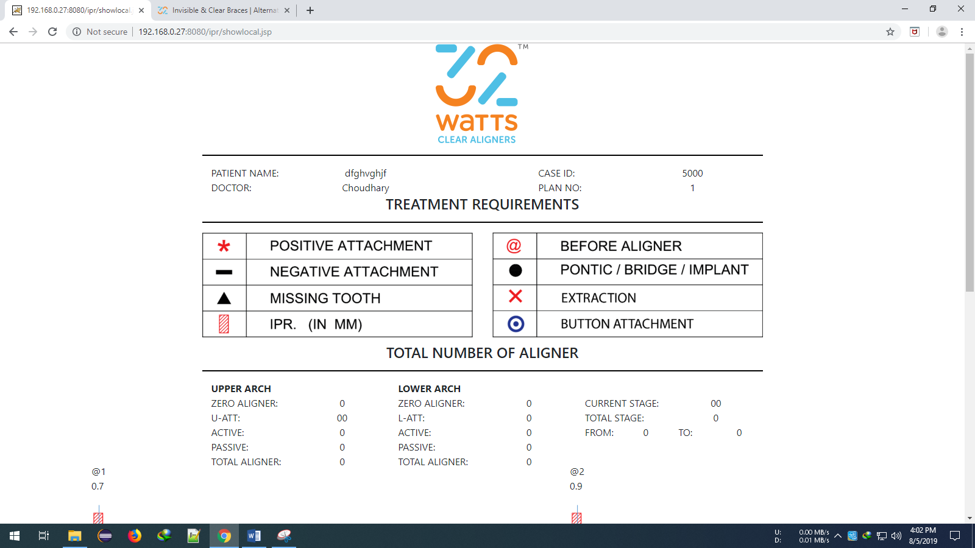

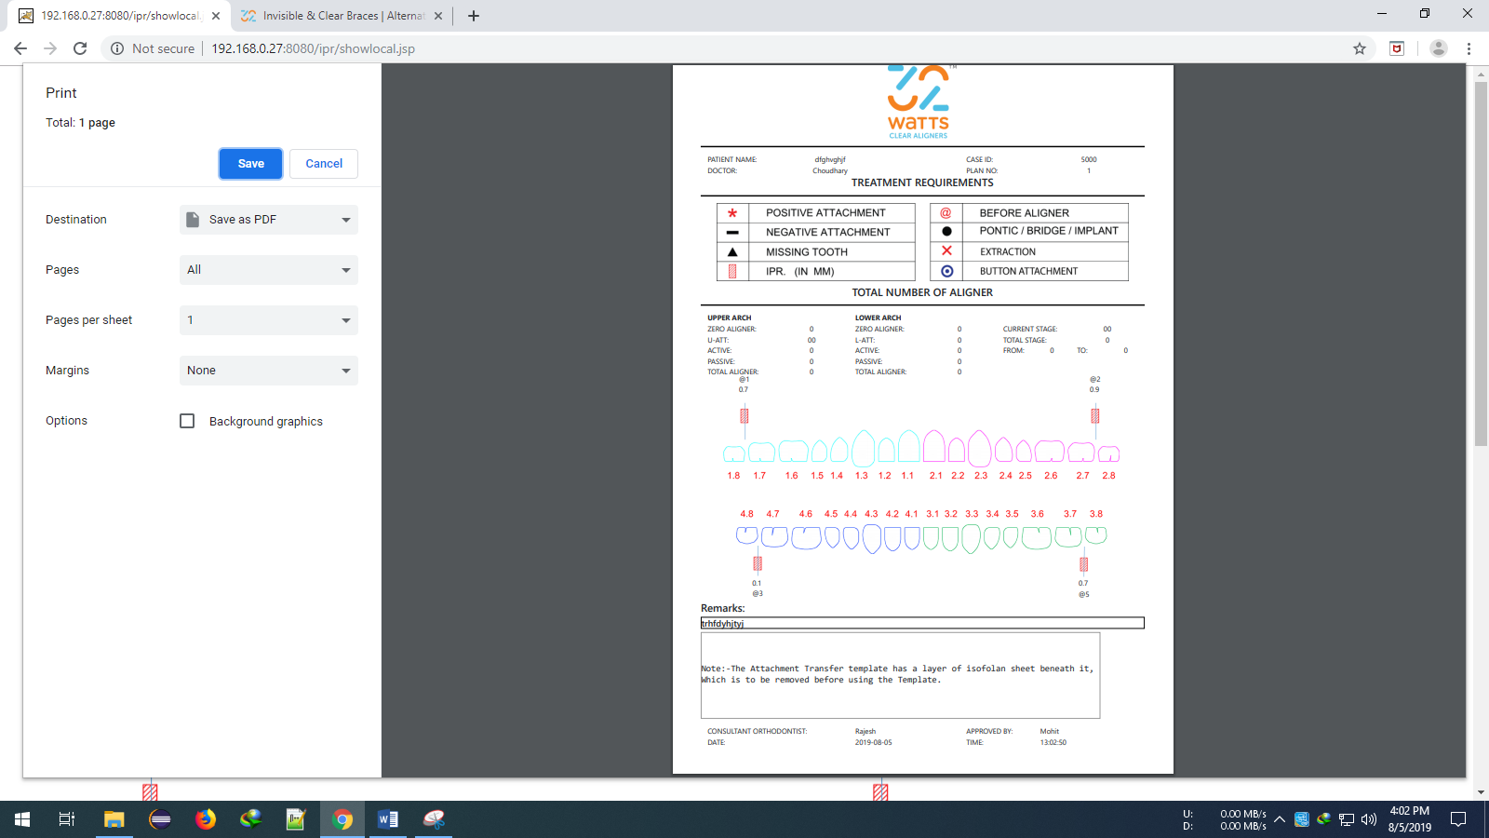

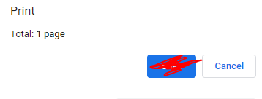

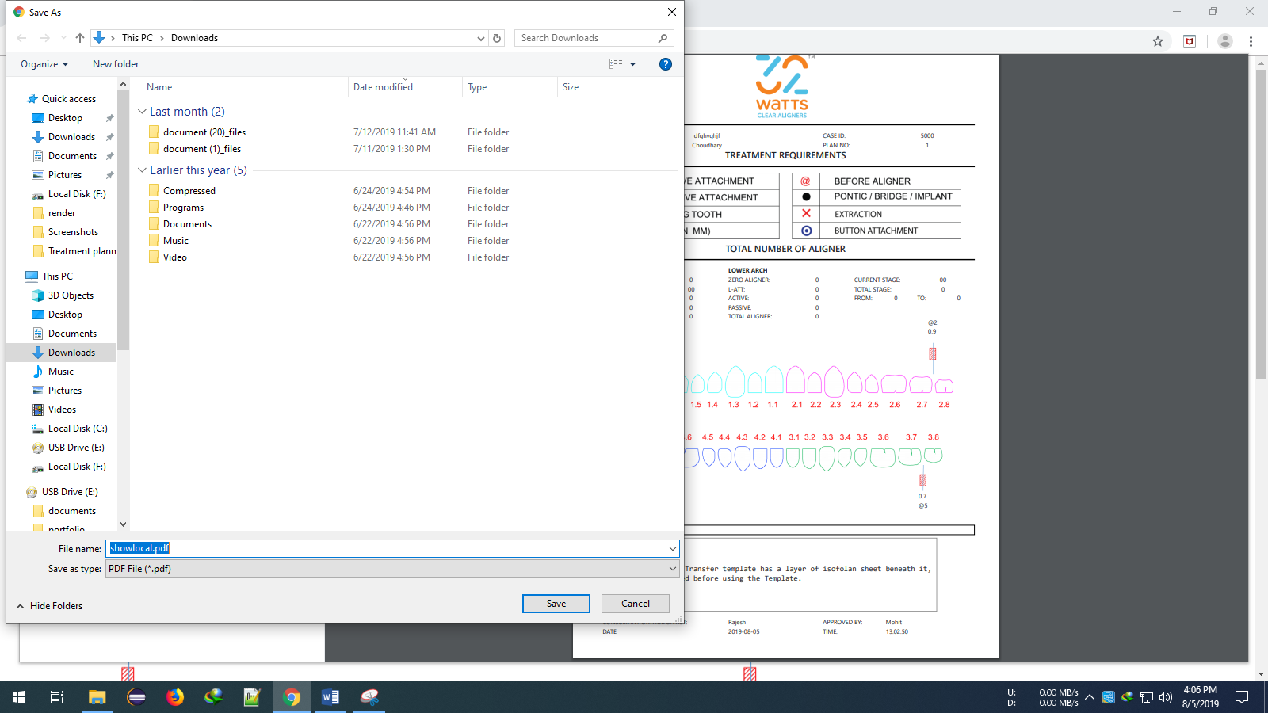

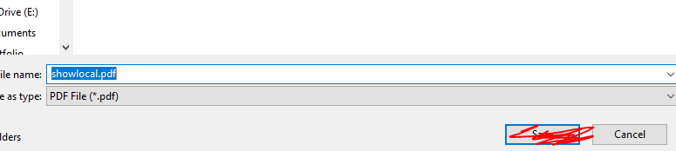

* How to Display Externally used IPR view
* Click on VIEW PREVIOUS DOCTOR IPR button on main page.
* logindoctor.jsp appears.
* Fill correct case id and plan no. If there is some mistake in case id and plan no then page will redirect to same page i.e logindoctor.jsp then again fill details.
* Click on get ipr.
* Externally used IPR will display.
* Press ctrl+p.
* Default chrome print appears.
* Destination: Save as PDF
* Pages: All
* Pages per sheet: 1
* Margins : NONE
* Options: Make unchecked Background Graphics
* Then click on blue color save button
* And save where you want.

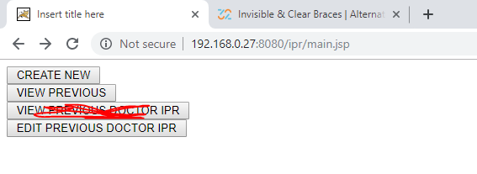

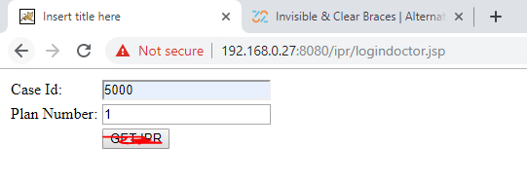

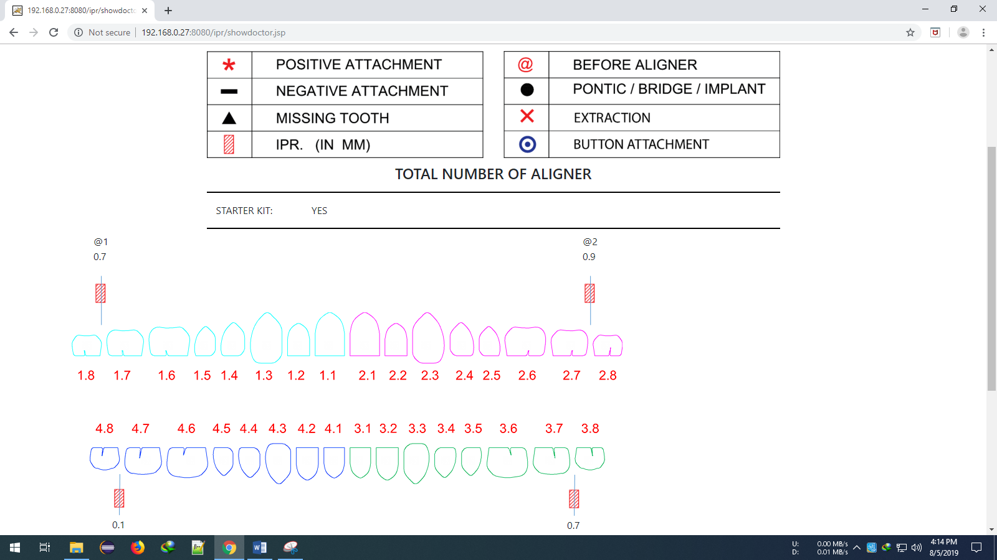

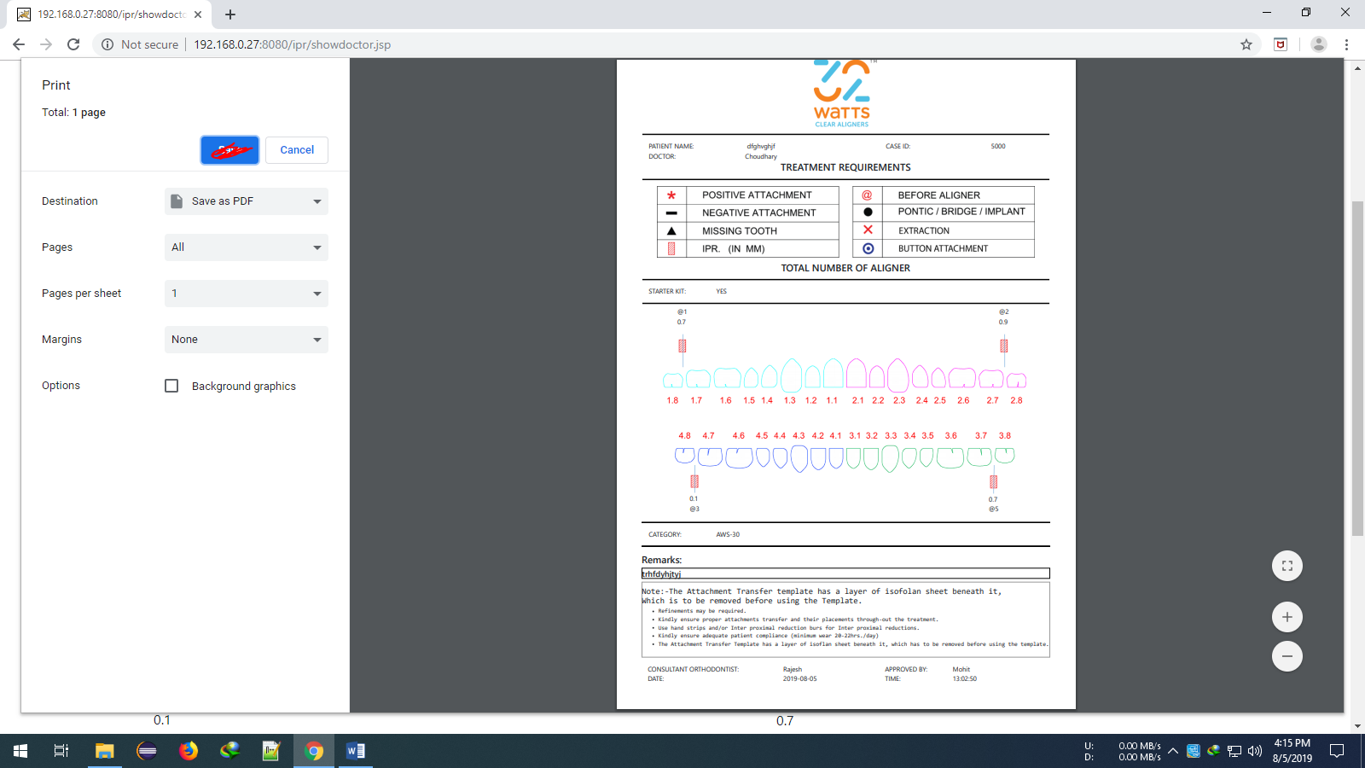 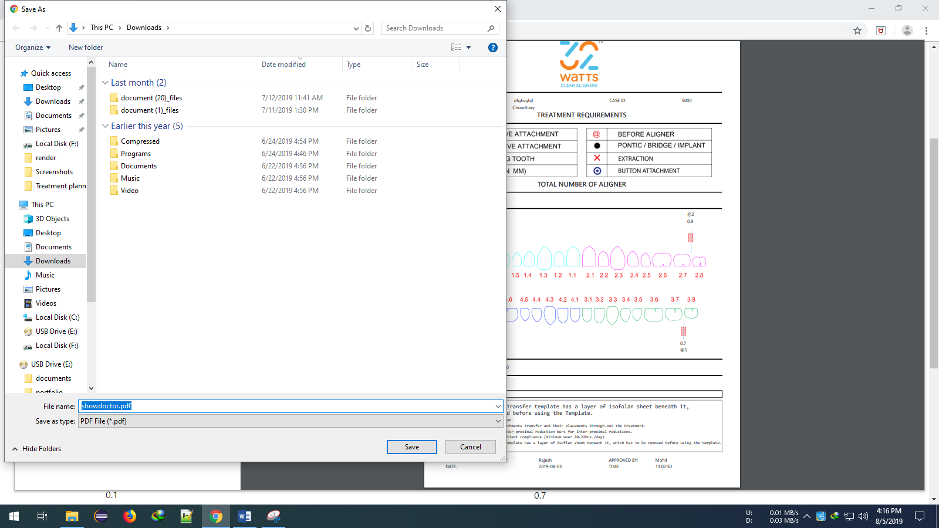

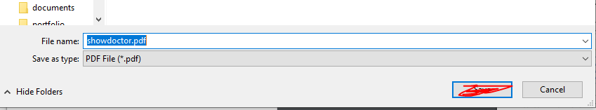

* How to edit IPR sheet
* Click on EDIT PREVIOUS DOCTOR IPR button on main page.
* loginedit.jsp appears.
* Fill correct case id and plan no. If there is some mistake in case id and plan no then page will redirect to same page i.e loginedit.jsp then again fill details.
* Already created IPR will open in edit mode.
* Make changes those you want.
* Please save it with a new plan no. If you save it with same case id and plan number then page will redirect to again on loginedit.jsp and saved unsuccessfully.
* If page will redirect to main.jsp then saved successfully.
* Rest of the things are just like creation of IPR.

